Title: | Door Control Unit  SW Architecture Version 1.2

History
Issue status  (Index) | Maturity/Date  (draft/invalid/valid)  (dd-mmm-yyyy) | Author  Department | Check/Release  Department | Description
1.0 | Draft  04-0ct-20 | Miguel Garcia | Miguel Garcia | Creation of the document
1.1 | Valid  21-Jan-2021 | Shiomar Salazar |  | First release of the Architecture Information.
1.2 | Valid  24-Mar-2021 | Shiomar Salazar |  | Second release, with the modifications made by the Development team.

Table of Contents
1 Purpose 4
2 Definitions and abbreviations 4
2.1 Definitions 4
2.2 Abbreviations 4
2.3 References 4
3 Realization constraints and targets 4
4 SW Functional Architecture 5
4.1 Table of functions 5
4.2 Table of functional Interfaces 5
4.3 Functional Interface 6
4.3.1 Use Case Diagram 6
4.3.2 Block Definition Diagram 7
4.4 Functional Interaction 7
4.4.1 Functional Sequence for Open/Close Driver Button. 7
4.4.2 Functional Sequence for Lock/Unlock Door Button. 8
5 SW Physical Architecture 9
5.1 Physical Decomposition 9
5.2 Table of SW components 9
5.3 Table of Physical Interfaces 10
5.4 Physical Interfaces 10
5.5 Physical Interaction 11
5.5.1 Physical Sequence for Open/Close Driver Button. 11
5.5.2 Physical Sequence for Lock/Unlock Driver Button. 11
5.6 Describe Dynamic Behavior 12
5.6.1 OS tasks 12
5.6.2 Interrupt Handling 13
5.6.3 Power Modes 13
5.7 Synchronization Mechanisms 13
6 Function to Physical Allocation 13
7 SW Requirements Allocation 14
8 SW Integration Plan 14
9 Functional Safety 14

Purpose
This document is intended to provide a complete and necessary guide on the Architectural structure for the Door Control Module; this document will provide different architectural views to show different aspects of the Door Control Module. In addition, this document will capture and summarize all he significant architectural decision, which have been made for this system.

Definitions and abbreviations

Definitions

Abbreviations
DCM | Door Control Module
SWC | Software Component
DD | Driver Door
PD | Passenger Door
RRD | Rear Right Driver
RLD | Rear Left Driver
SW | Software
HAL | Hardware Abstraction Layer

References
N° | Document name | Reference
1 | “Traceability Matrix Template.xls” Version 1 | \V_Process_SSalaza\V-Cycle Process\1.0 Requirements\
2 | “Proyecto_DoorControlModule.docx” | \V_Process_SSalazar\

Realization constraints and targets

The DCM project is required to fulfill all the Requirements specified by the client (please refer to referenced documents), which at the moment of the creation of this document the target of this systems includes Door Locking feature, Window Control Features, HW Diagnostics which could be subject to changes.
The system shall be able to fulfill the previously mentioned features for all the Variants, including but limited to DD, PD, RRD and RLD.

During the development process, is also required to the system to provide a Debugging Information feature and Testing Interface Feature, which shall be disable on every Production Release.

SW Functional Architecture

Table of functions
Function Name | Description
DBG_Print | This function will post a serial Debug Log for testing proposes.
DBG_Error | This function will post a serial Error Log for testing proposes.
getVariantId | This function will return the SW Variant read during initialization.
ProcessTesterCMD | This function will handle the entire CAN Test Operation.
ButtonManager_Op | This function will monitor the current state of the button based on the variant. Also will perform the debounce algorithms.
getBtnList | This function will return the current state of the Buttons after the debounce.
setBtnList | This function will inform the ButtonManager that the DCM_App already process the Button list provided.
determineDoorLockingStatus | This function will return the current position of the window.
determineWindowPosition | This function will return the current state of the door locking.
setActuatorAction | This function will trigger all the actuators actions.
processWindowControl | This periodic function will control the Window logic.
processDoorControl | This periodic function will control the Door Locking logic.
setHWMotorStatus | This function will allow reporting an Error on the Window actuator.
setHWSolenoidStatus | This function will allow reporting an Error on the Door Locking Actuator.
DCM_Process_Req | This function will execute the DCM Algorithm periodically.
setManualFlag | This function will inform the DCM_App that there is a button request pending.
setTestFlag | This function will inform the DCM_App that there is a testing request pending.
APP_RxCAN_process | This function will handle the Reception of the CAN Msg.
APP_CAN10ms_txProcess | This function will handle the Transmission of the CAN Msg.
APP_Get_avlbl_msg_XXXX | These functions will inform of the CAN Msg to be processed.
APP_Clr_avlbl_msg_XXXX | These functions will inform that a CAN Msg was processed.
APP_CAN_DCM_XX_update_msg XXXX | These functions will update the values of the Tx CAN Msg.
APP_CAN_DCM_XX_get_msg XXXX | These functions will provide the values of the Rx CAN Msg.

Table of functional Interfaces
Signal/Event | Description
VariantID | Provide the information of the current SW Variant.
ButtonPress | Provide Information of the type of press present by a button.
Btn_list | Provide a list of type ButtonPress_t containing the information of each button of the DCM.
S_BRAKE_2 | Provide the data of the BAKE 2 CAN Msg.
S_BCM_2 | Provide the data of the BCM 2 CAN Msg.
S_BCM_5 | Provide the data of the BCM 5 CAN Msg.
S_DCU_1 | Provide the data of the DCU 1 CAN Msg.
S_DCU_2 | Provide the data of the DCU 2 CAN Msg.
S_DCU_3 | Provide the data of the DCU 3 CAN Msg.
S_DCU_4 | Provide the data of the DCU 4 CAN Msg.
Module | Provide the information of the Module that send the DBG Print/Error.
Text_print | Provide the text to be send over the DBG Print.
Status_Door | Provide information of the Status of the Door Locking.
Status_Wind | Provide information of the Status of the Window Position.
Text_error | Provide the text to be send over the DBG Error.
Flag_manual | Provide information of a Manual Request.
Flag_tester | Provide information of a Tester Request.
Cmd | Provide the commands to execute after a tester request.
Status_motor | Provide the status of the HW Motor for window movement.
Status_sole | Provide the status of the Solenoid used for the Door Locking.
Action | Provide information of the action taken by the actuator.
Data_struct | Provide information between the different CAN IL.
Flag_can | Provide information on CAN Msg Available flag.

Functional Interface
In order to show the static behavior of the system two diagrams will be use:
- Use Case Diagram: to show the system boundaries, the actors of the system and the relationships between them.
- Functional Block Definition Diagram: to show all the functionalities that DCM System shall provide.

Use Case Diagram
The Use Case diagram present a High Level description of the main functionalities that the DCM will perform, in this Diagram all Actors can be identified, the use cases and their relationship between them; the system boundary allow to define the limits of our DCM, so our SW can focus on these Use Cases to fulfill the overall functionalities requested by the customer.

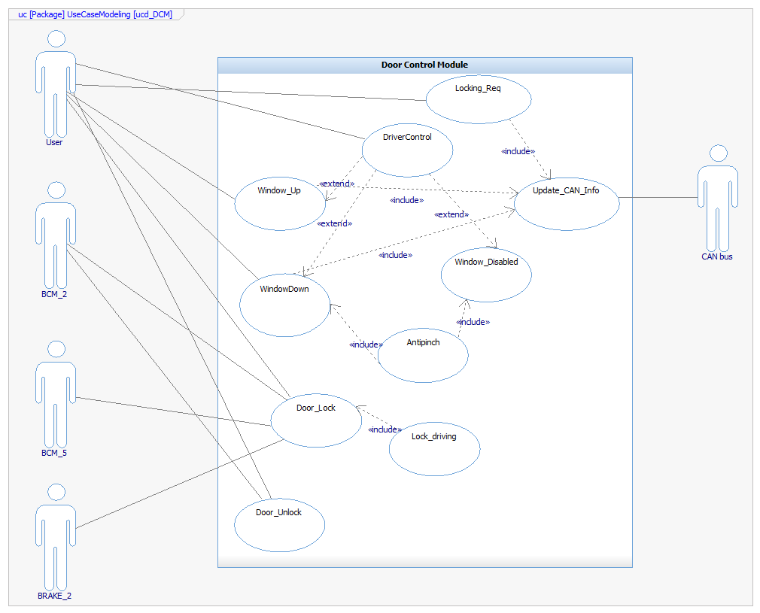

Block Definition Diagram
The Functional Block Definition Diagram contain all the Function that the SW will have to provide to ensure the complete fulfillment of the costumers requirements. In the diagram, the information exchange between function can be seen.
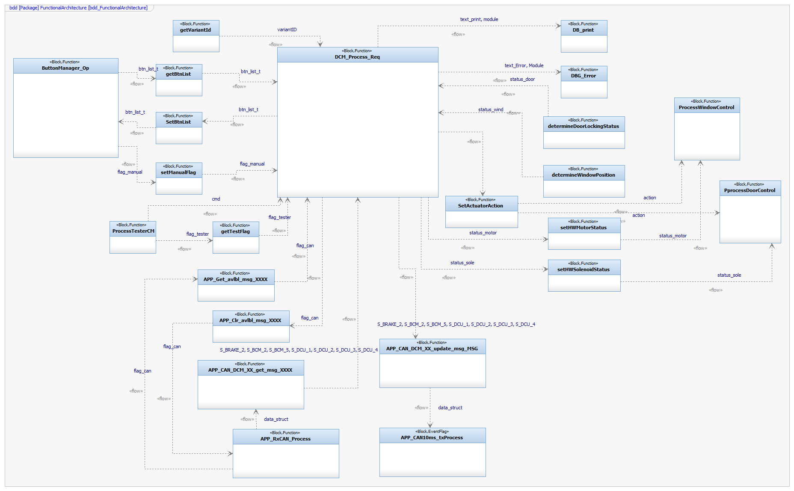

Functional Interaction

Functional Sequence for Open/Close Driver Button.
In the following sequence diagram is shown the functional steps for the Open/Close Button arbitration for the Driver Door Variant. Also is show the different Inputs for the Process_DCM function, like the Button HW Validation, The HW Window Validation and the Variant ID.

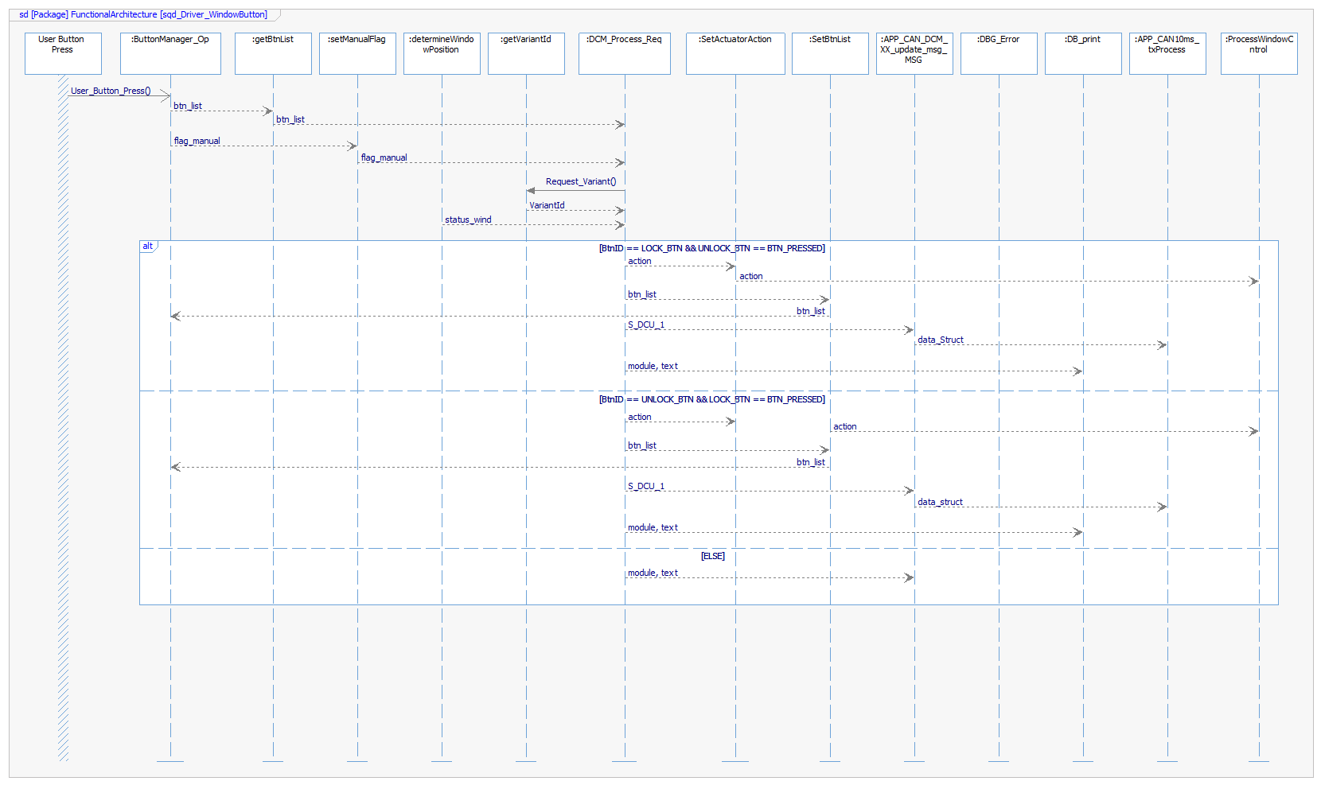

Functional Sequence for Lock/Unlock Door Button.
In the following sequence diagram is shown the functional steps for the Lock/Unlock Button arbitration for the Driver Door Variant. Also is show the different Inputs for the Process_DCM function, like the Button HW Validation, The HW Door Validation and the Variant ID.

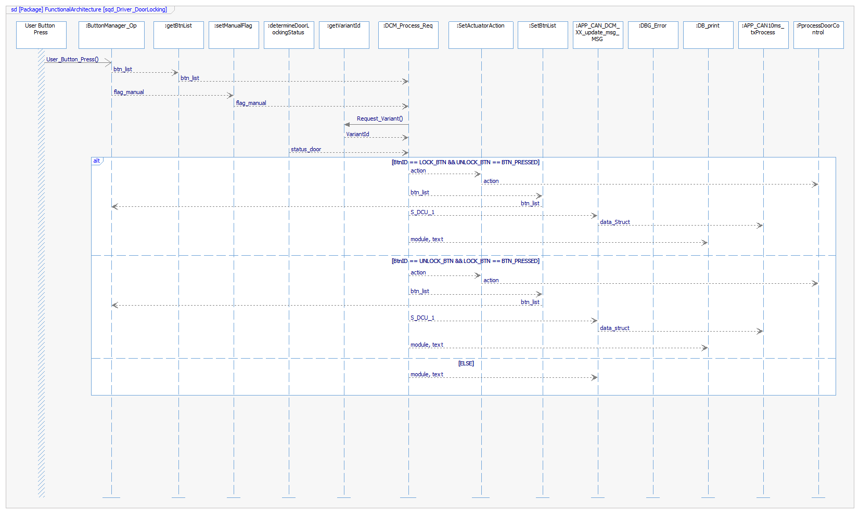

SW Physical Architecture

Physical Decomposition
For the Physical Architecture I was define three main layers called:
- MCU_Layer: to handle all the Low Level SW related to the control of the Ports and the Pin of the selected MCU.
- HW_Layer: to provide an abstraction Layer on the MCU.
- APP layer: to handle all the logic and algorithm required to satisfy the customer requirements.

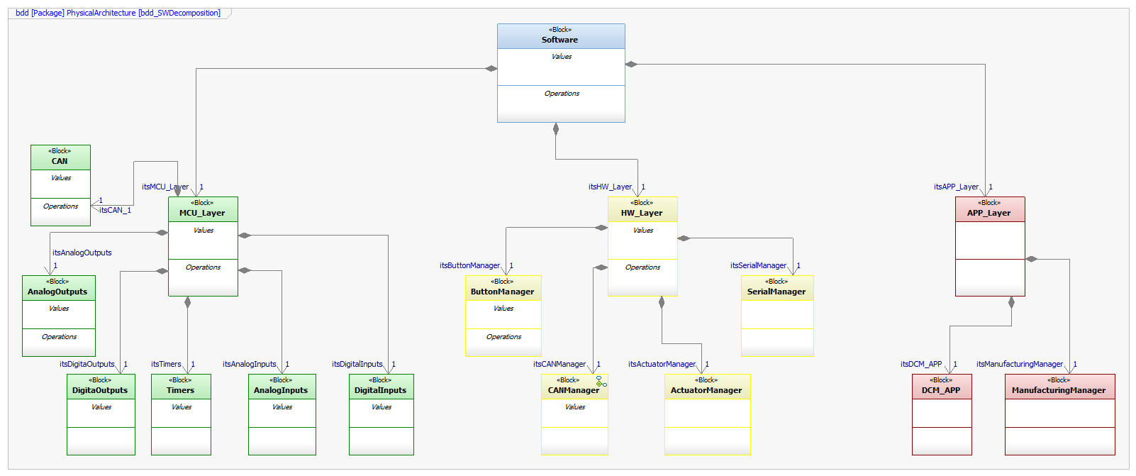

Table of SW components
SWC Name | Description | Estimated Size (KB)
AnalogOutputs | HAL layer to control the Analog Outputs of the MCU. | 3 KB
DigitalOutputs | HAL layer to control the Digital Outputs of the MCU. | 3 KB
Timers | HAL layer to control the Timers of the MCU. | 3 KB
AnalogInputs | HAL layer to control the Analog Input of the MCU. | 3 KB
DigitalInputs | HAL layer to control the Analog Input of the MCU. | 3 KB
ButtonManager | SWC to provide the necessary interfaces to control the Input Button. | 3 KB
CANManager | SWC to provide the necessary interfaces to control the CAN transceiver to Read and Post Message in the CAN Bus. | 3 KB
ActuatorManager | SWC to provide the necessary interfaces to control the two Actuators (Window and Door Locking). | 3 KB
SerialManager | SWC to provide the necessary interfaces to control the Serial IC for Debug Message. | 3 KB
DCM_App | SWC to provide the necessary interfaces to control the Door Control Algorithm, to process the Inputs and produce the appropriate outputs. | 3 KB
ManufacturingManager | SWC to provide the necessary interfaces to control all the manufacturing features including module configuration and tester features. | 3 KB

Table of Physical Interfaces
Operation | Description | Implemented API’s
iCANTransmit | This interface provide the method to write the necessary CAN message into de CAN bus. | APP_CAN_DCM_XX_update_msg XXXX
iCANRecieve | This interface provide the methods to read the necessary CAN message into de CAN bus. | APP_Get_avlbl_msg_XXXX  APP_Clr_avlbl_msg_XXXX  APP_CAN_DCM_XX_get_msg XXXX
iVariant | This Interface provide the method to retrieve the Module Configuration information. | getVariantId
iActuator | This Interface provide the methods to get the current actuator state and to perform an action on a specific actuator. | determineDoorLockingStatus  determineWindowPosition  setActuatorAction  setHWMotorStatus  setHWSolenoidStatus
iSerialLog | This Interface provide the methods to post the debug message on the serial bus. | DGB_Error  DGB_Print
iButton | This Interface provide the methods to get the button and the press type to be processed. | getBtnList  setBtnList
iApp | This Interface provide the methods to trigger the processing of the information. | setManualFlag  setTestFlag

Physical Interfaces
In the following diagram is showing the necessary interface to transfer the information through the different SWC.
In the diagram is possible to point out the following SW characteristic:
- DCM_APP is the main Function, which will process the inputs and generate all the respective outputs.
- CANManager has defined two interfaces one for reading the expected message in the CAN bus, but also an interface for writing the output CAN signal on the bus; so this SWC is an input and output for the main algorithm.
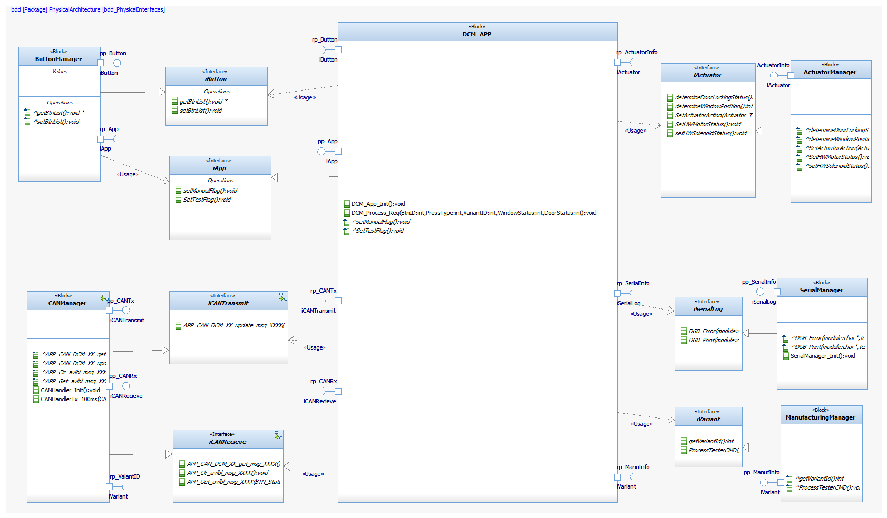

Physical Interaction

Physical Sequence for Open/Close Driver Button.
The following diagram show the sequence for the Open/Close Button action for window feature on the system with the DriverDoor Configuration.
In the diagram, we can see all the data flow necessary for the DCM algorithm to work in this specific case with the respective error path that could be identify on the processing of the algorithm.

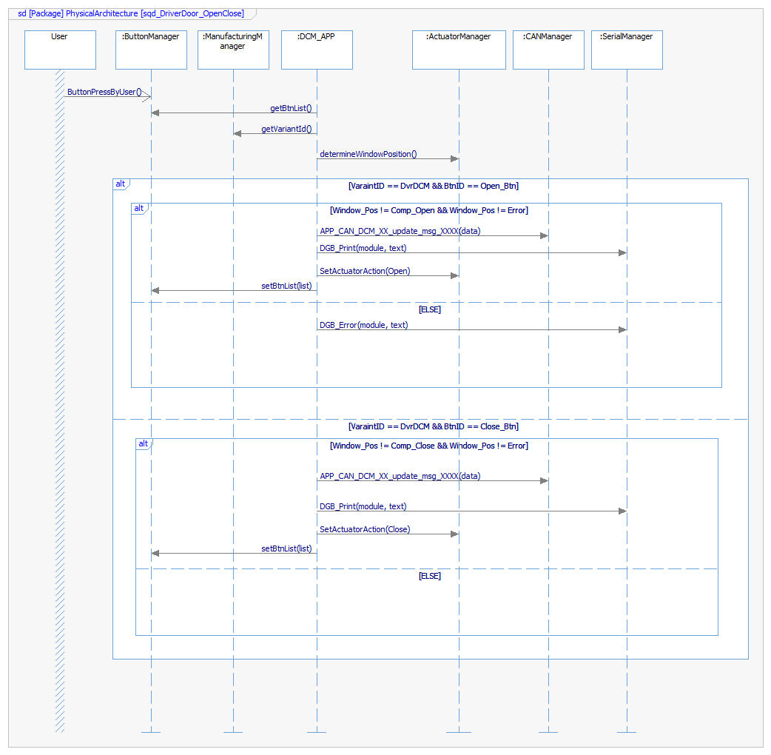

Physical Sequence for Lock/Unlock Driver Button.
The following diagram show the sequence for the Lock/Unlock Button action for window feature on the system with the DriverDoor Configuration.
In the diagram, we can see all the data flow necessary for the DCM algorithm to work in this specific case with the respective error path that could be identify on the processing of the algorithm.

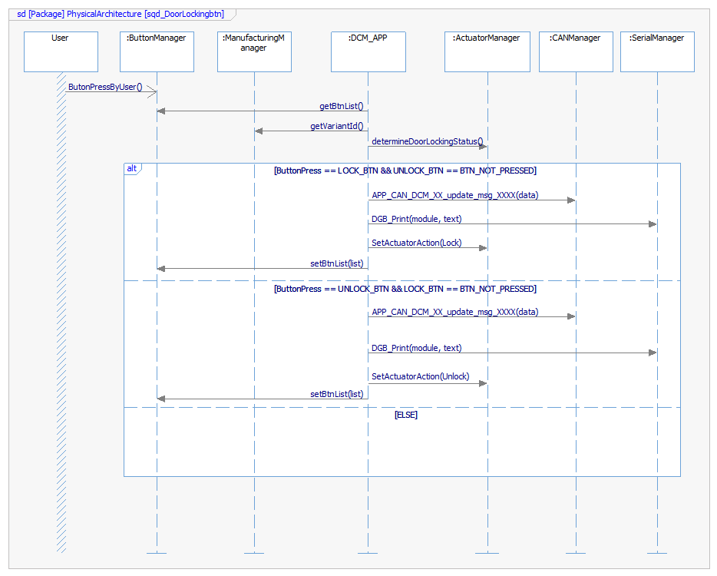

Describe Dynamic Behavior
On this section of the document will describe all the required OS tasks that will be define in the whole system, in each SWDD (Software Detailed Design) this task will be use to map every SWC task into one of the following OS task.
In the following tables the priority field will be following, the rule of the lower priority is the most important one.

OS tasks
OS task | Description | Periodicity | Period | Priority | CPU Load
Init_task | This task will perform any function related to the initialization process. | No | Each Power Up Process | 1 | 2 %
10ms_task | This task will executed every 10 ms. | Yes | 10 ms | 3 | 10 %
50ms_task | This task will executed every 50 ms. | Yes | 50 ms | 4 | 20 %
100ms_task | This task will executed every 100 ms. | Yes | 100 ms | 5 | 30 %

Interrupt Handling
ISR task | Description | Priority | CPU Load
CAN_Rx_ISR | Interrupt used to indicate every reception of a CAN message. | 3 | 1 %
Timer1_ISR | Interrupt to indicate each OS systick. | 1 | 0.5%

Power Modes
For the system DCM will not have any power mode, this module will not perform any transition nor action related to the Power Consumption.
The DCM will be always on High Power mode during all their lifetime.

Synchronization Mechanisms
The DCM system will use two synchronization methods, listed in the following table:
Method | Description use
Critical Section | To prevent the unwanted interruption on critical section of the section, a Critical Section will be set to prevent the CAN transition to be interrupted and miss the Tx window.
Task Prioritization | To prevent race conditions and ensure that every task has the required data for their execution all task will have the correct priority set.

Function to Physical Allocation

Function | SW component | Clarification
DBG_Print | SerialManager
DBG_Error | SerialManager
getVariantId | ManufacturingManager
ProcessTesterCMD | ManufacturingManager
ButtonManager | ButtonManager
getBtnList | ButtonManager
setBtnList | ButtonManager
determineDoorLockingStatus | ActuatorManager
determineWindowPosition | ActuatorManager
setActuatorAction | ActuatorManager
processWindowControl | ActuatorManager
processDoorControl | DCM_App
setHWMotorStatus | DCM_App
APP_RxCAN_process | CANManager
APP_CAN10ms_txProcess | CANManager
APP_Get_avlbl_msg_XXXX | CANManager
APP_Clr_avlbl_msg_XXXX | CANManager
APP_CAN_DCM_XX_update_msg_XXXX | CANManager
APP_CAN_DCM_XX_get_msg_XXXX | CANManager

SW Requirements Allocation
For the requirements allocation please refer to the “Traceability Matrix Template.xls” file, under Columns R and Q, can be verify in every requirement, which SWC will implement it.

SW Integration Plan

Integration Step | Description | SW components | Comments
1 | MCU Layer Integration | MCU Layer. | Integrate the MCU abstraction layer.
2 | MCU configuration (ISR, timers, etc). | MCU Layer. | Provide the interfaces to configure and control the MCU layer.
3 | RTOS integration. | MCU Layer.
4 | HW Layer integration (CANManager) | CANManager | Enable the reception and transmission of CAN messages.
5 | HW Layer Integration | ActuatorManager  ButtonManager  SerialManager | Enable the reception of inputs event and star working on the debug serial log to avoid going blind.
6 | Main app SWC integration | DCM_APP | Start working on integrate main functionality of the DCM.
7 | Manufacturing integration | ManufacturingManager | Allow Manufacturing configuration of the DCM.
8 | Re-integrate App SWC | DCM_APP | After integrate the variant reading re-work the main app to support the rest of the variants.
9 | Tester feature integration | ManufacturingManager | Allow test command for extensive test procedure.

Functional Safety
This chapter will be fill during Module 5

